What is Jenkins used for in AWS?
Jenkins helps you:
- Automate code build & deployment pipelines for AWS workloads.
- Integrate with AWS services such as:
  - EC2 – Deploy Jenkins on an EC2 instance.
  - ECS/EKS (containers) – Automate containerized app deployments.
  - S3 – Store build artifacts.
  - CodeCommit – Use as a source repository.
  - CodeDeploy – Deploy applications automatically.
  - Lambda – Trigger serverless deployments.
  - CloudFormation/Terraform – Provision infrastructure as code.
- Enable continuous integration (build/test every commit).
- Enable continuous delivery (automated release to staging/production).

How Jenkins Works with AWS
- Deployment options:
  - Install Jenkins on EC2 (most common).
  - Use Jenkins on Kubernetes (EKS).
  - Run Jenkins as a Docker container (ECS/Fargate).
  - Use the official AWS Jenkins AMI from AWS Marketplace.
- Plugins for AWS:
Jenkins has plugins to integrate directly with AWS:
  - AWS Credentials Plugin – Manage AWS IAM keys securely.
  - Amazon EC2 Plugin – Auto-scale Jenkins build agents using EC2.
  - Pipeline: AWS Steps – Interact with AWS services via pipeline.
  - S3 Publisher Plugin – Upload artifacts to S3.

Example AWS Jenkins CI/CD Pipeline
- Code is pushed to CodeCommit (or GitHub/Bitbucket).
- Jenkins pulls the code, builds it (e.g., Maven, Gradle, npm).
- Unit/integration tests run inside Jenkins.
- Build artifacts are uploaded to S3 or ECR.
- Jenkins triggers a CodeDeploy or ECS/EKS deployment.
- Optional: Notify via SNS/Slack.

Why Use Jenkins on AWS?
- Full control over CI/CD environment.
- Integrates with all AWS services.
- Scales using EC2 Auto Scaling or Kubernetes.
- Supports hybrid environments (on-prem + AWS).

- Install Jenkins and run Jenkins on port number 8081.
1ST we need instances to download all application / services.
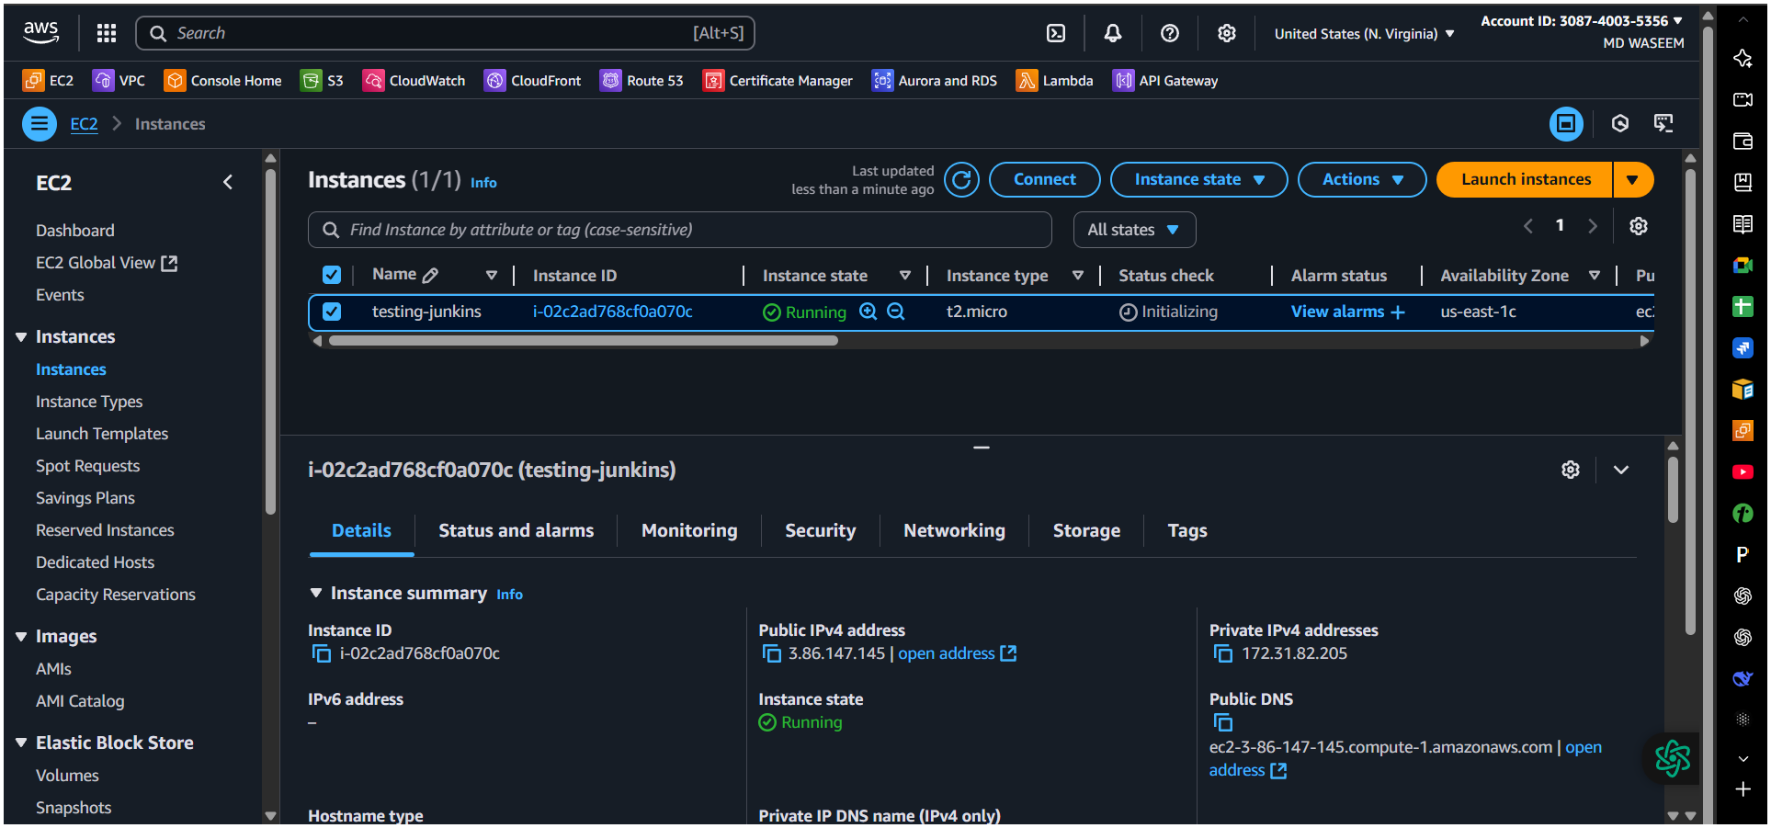
To download jenkins
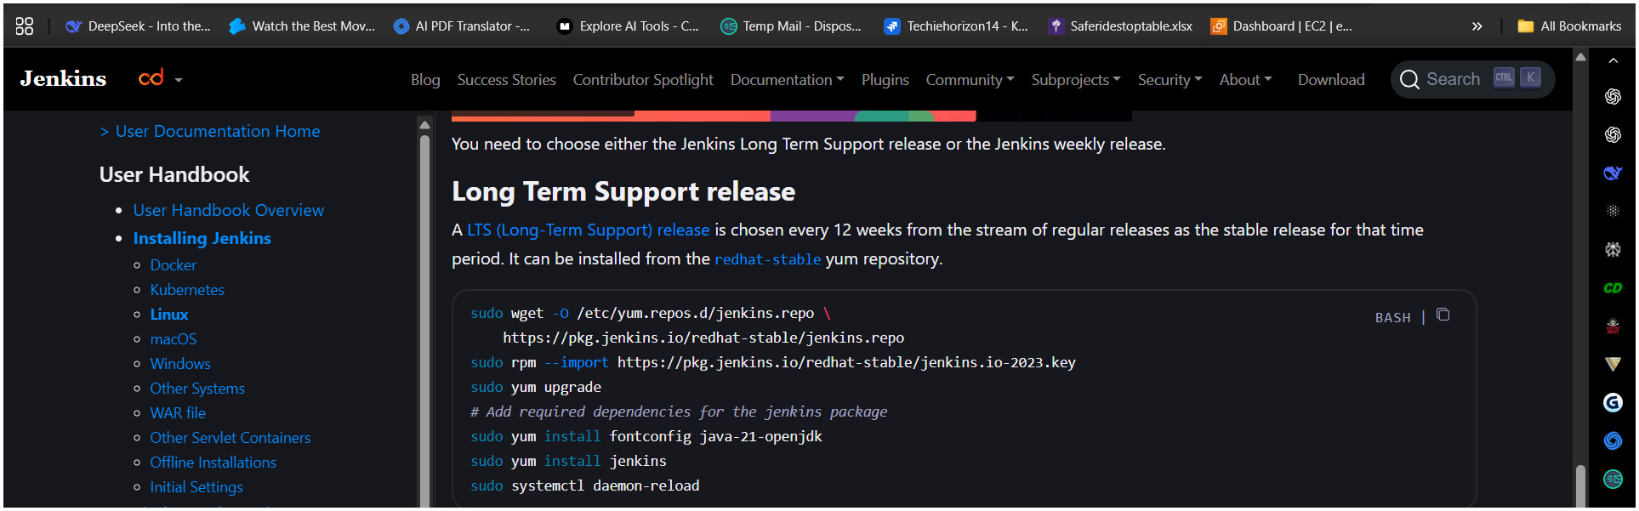
sudo wget -O /etc/yum.repos.d/jenkins.repo \
https://pkg.jenkins.io/redhat-stable/jenkins.repo
sudo rpm --import https://pkg.jenkins.io/redhat-stable/jenkins.io-2023.key
sudo yum upgrade
# Add required dependencies for the jenkins package
sudo yum install fontconfig java-21-openjdk
or
sudo amazon-linux-extras enable corretto17
sudo yum install -y java-17-amazon-corretto
sudo yum install jenkins
sudo systemctl daemon-reload

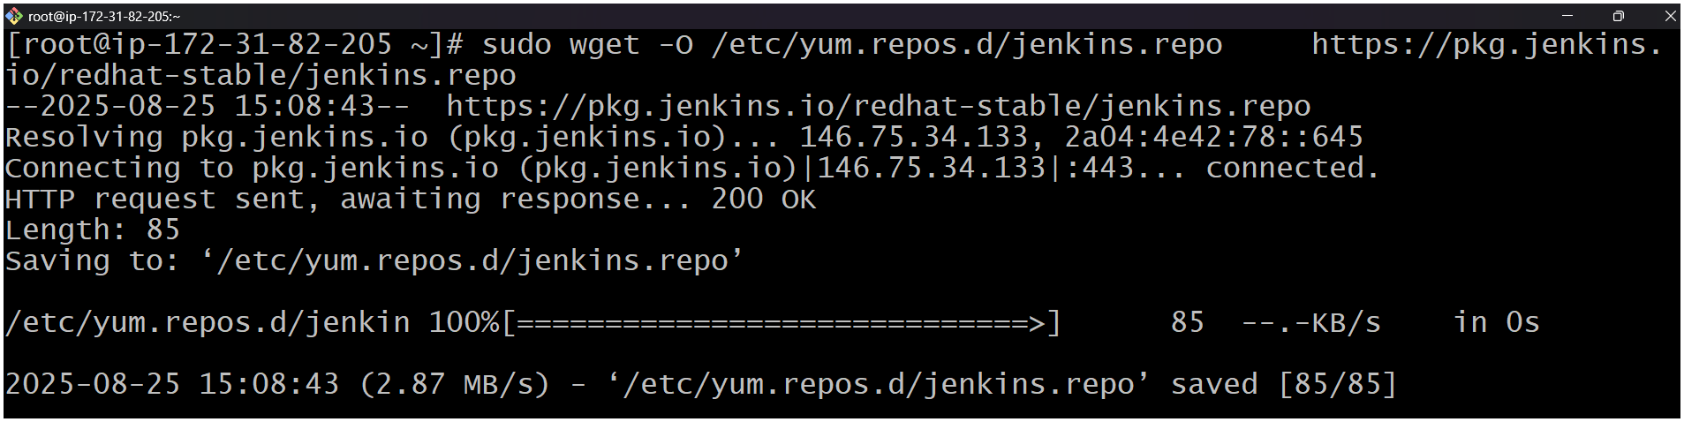
Here we have changed the port no for Jenkins from 8080 to 8081
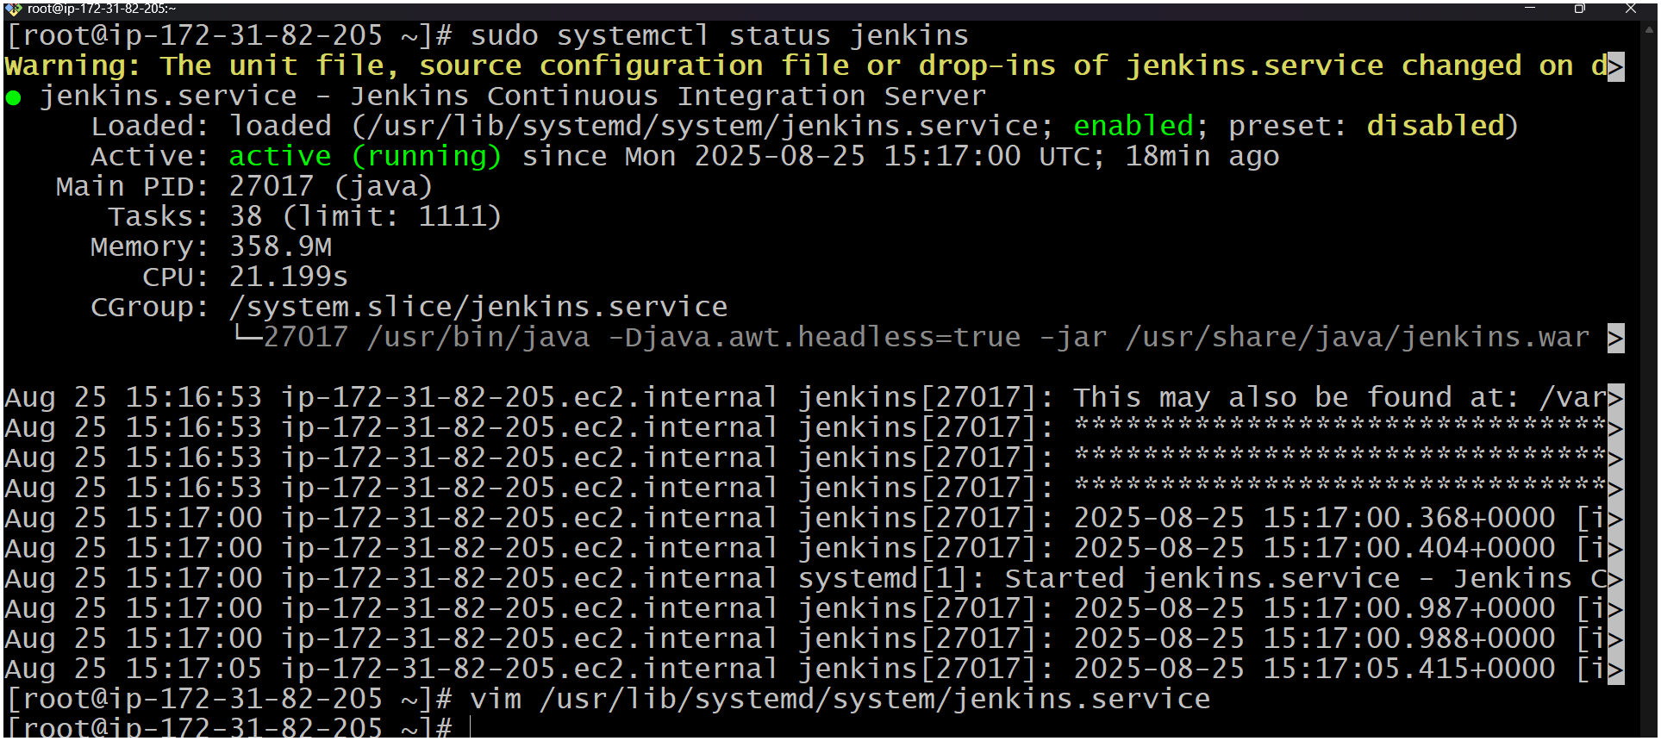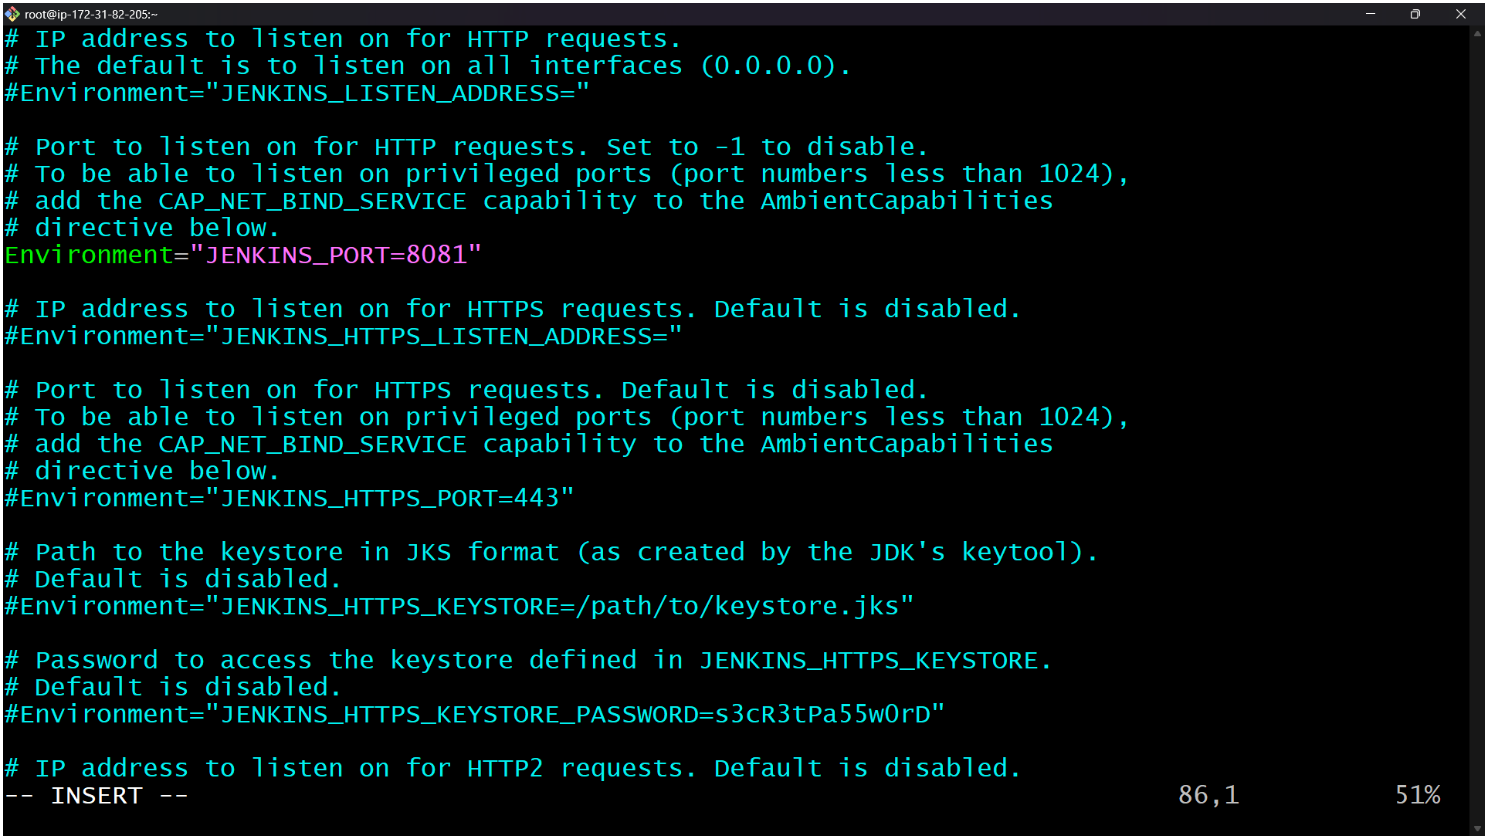

- Secure Jenkins server.
To get the password for the Jenkins ( default password ) command is :
sudo cat /var/lib/jenkins/secrets/initialAdminPassword
After generating password / secrets copy the above password and paste In the Jenkins admin new login page and then change the password by clicking at top right your user name securitypassword ( change the password as per your need )
Login in to Jenkins by the public ip address with :8080/ at the end of the url
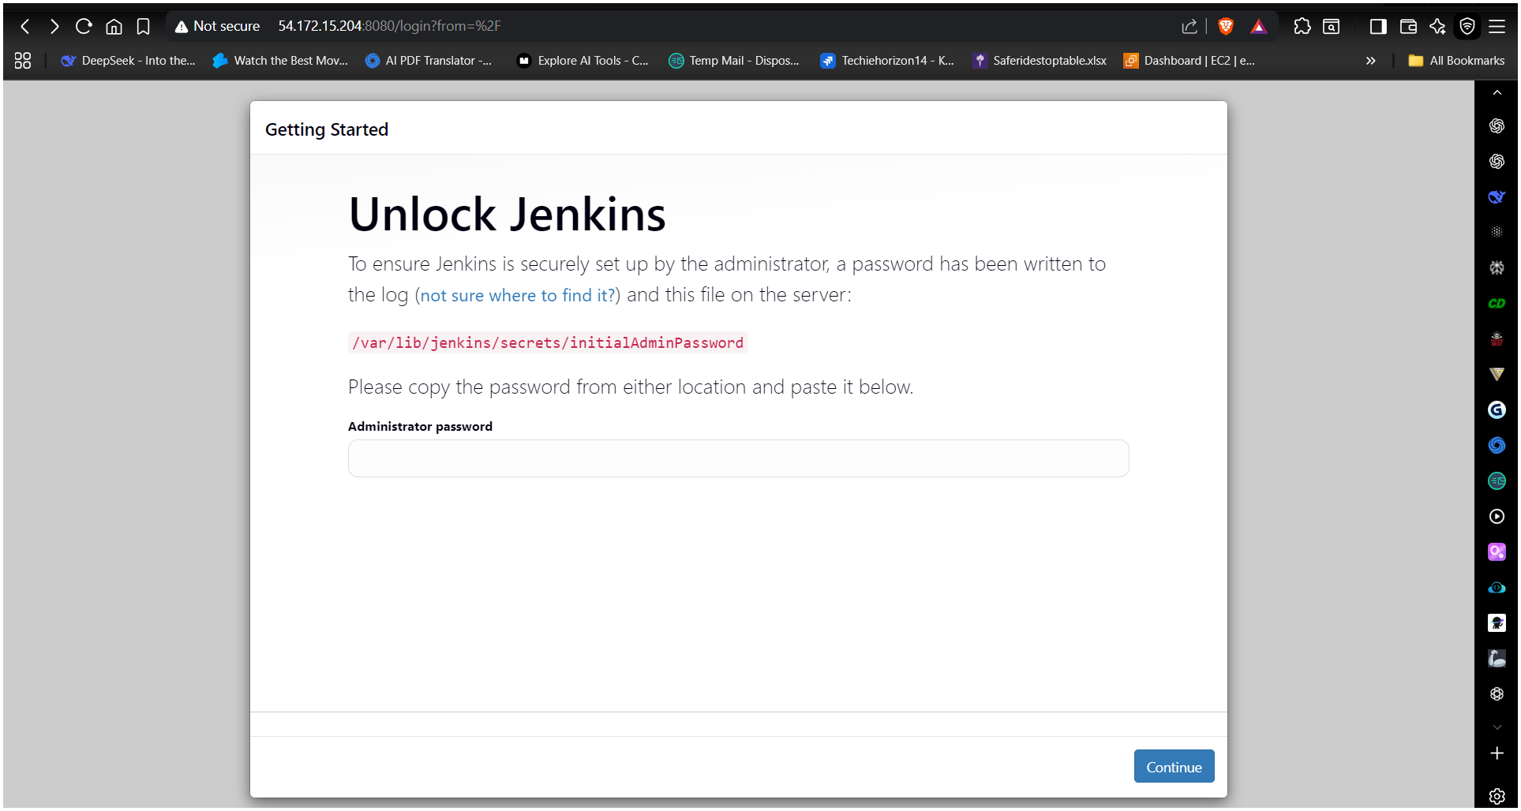
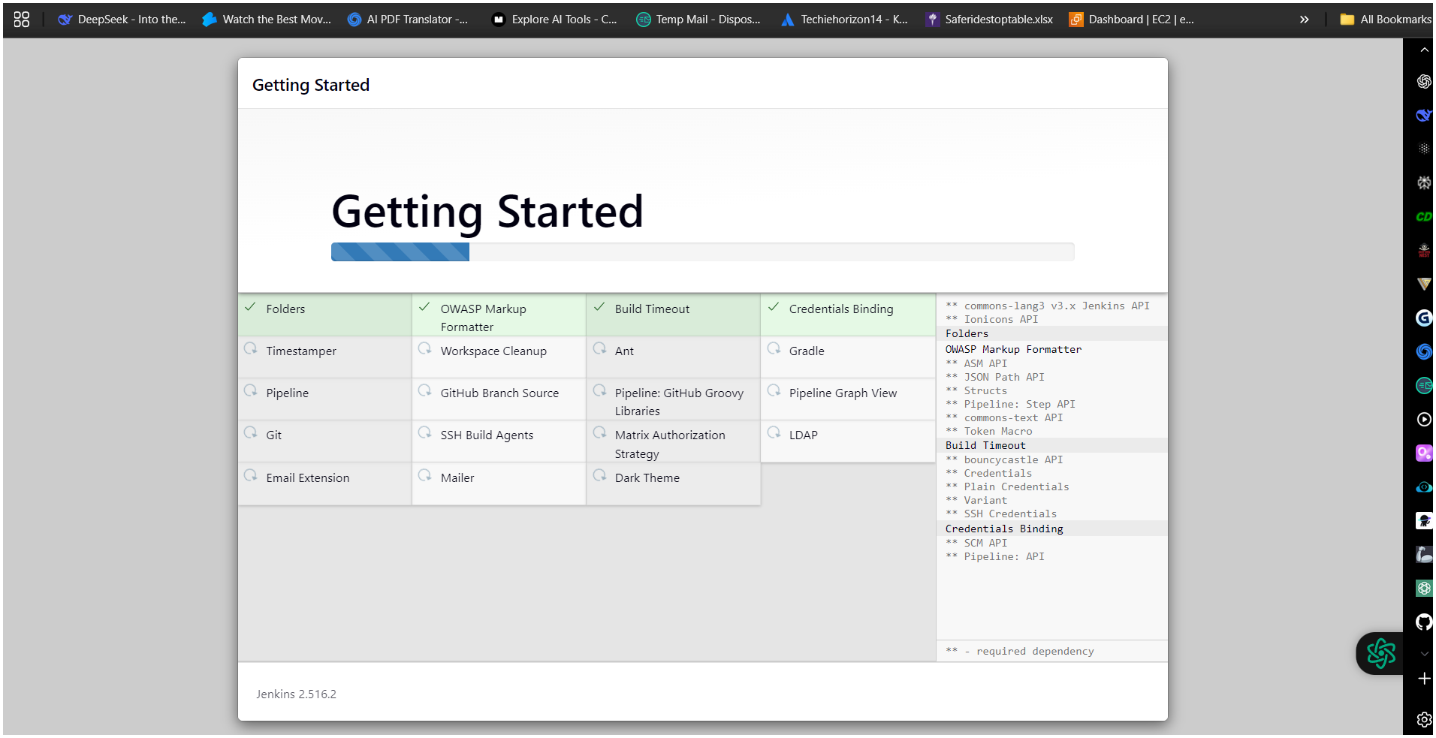
Here we have changed the password / passcode for Jenkins.

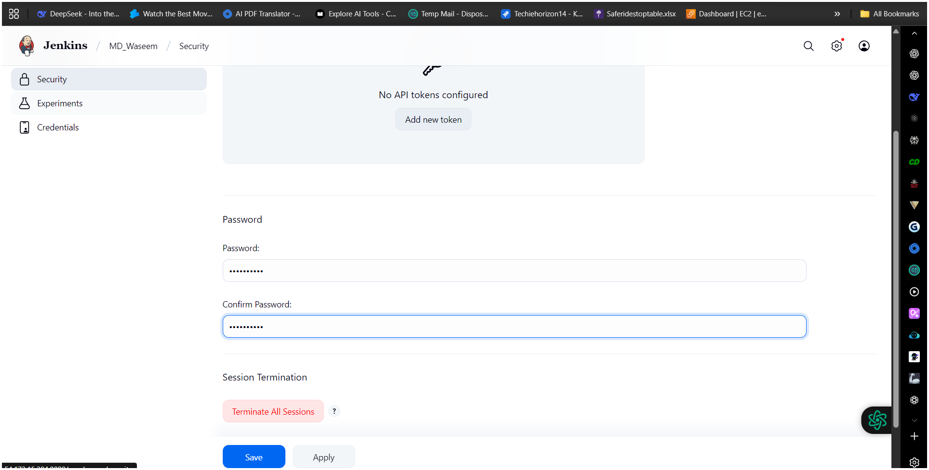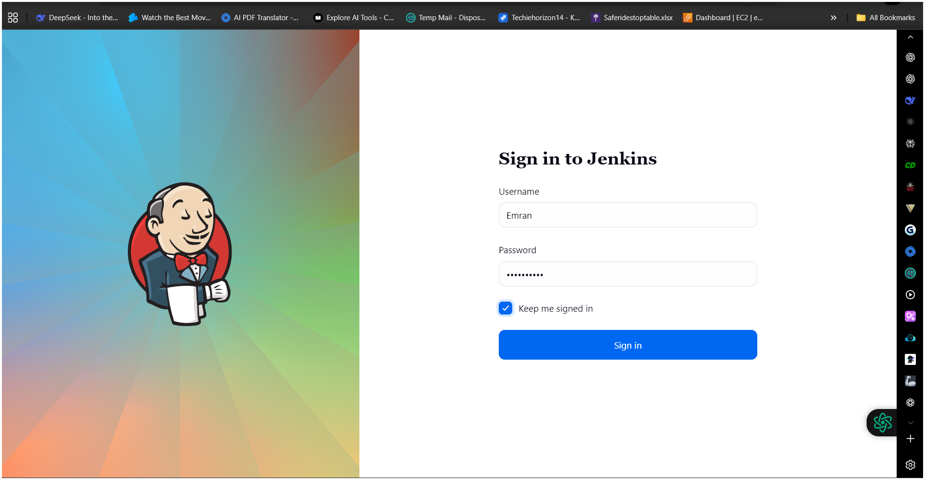

What are Jenkins Plugins?
- Small software add-ons that enhance Jenkins.
- Written in Java and maintained by the Jenkins community.
- Installed from the Jenkins Plugin Manager.

Why are Plugins Important in Jenkins?
- They make Jenkins highly customizable and flexible.
- Allow integration with:
  - Version control systems (Git, GitHub, GitLab, Bitbucket, CodeCommit)
  - Cloud services (AWS, Azure, GCP)
  - Build tools (Maven, Gradle, npm)
  - Containers & Orchestration (Docker, Kubernetes, ECS, EKS)
  - Notification tools (Slack, Email, Teams)
- Without plugins, Jenkins would only provide basic CI/CD capabilities.

Examples of Common Jenkins Plugins
- Git Plugin – Integrates Git repositories.
- Pipeline Plugin – Enables scripted/declarative pipelines.
- Role-Based Authorization Strategy – Manage users & roles.
- Amazon EC2 Plugin – Auto-provision EC2 agents.
- Blue Ocean – Modern UI for Jenkins pipelines.
- Slack Notification Plugin – Send build alerts to Slack.
- Credentials Binding Plugin – Securely handle credentials.

How to Manage Plugins in Jenkins
- Go to Manage Jenkins → Manage Plugins.
- There are four tabs:
  - Updates – Shows plugins that need updates.
  - Available – Browse and install new plugins.
  - Installed – Shows already installed plugins.
  - Advanced – Manual upload/download.
- Select desired plugins → Install without restart or download now and install after restart.

1. Job (Project)
A Job in Jenkins refers to a task or project that Jenkins executes. It defines what should be done, such as building, testing, or deploying code.
Types of Jobs:
- Freestyle Project: Basic job type with manual configuration.
- Pipeline: Scripted jobs (Jenkinsfile) for CI/CD workflows.
- Multibranch Pipeline: Automatically creates jobs for multiple branches in source control.
- Matrix Project: Runs the same job on multiple environments/configurations.
- External Job: Monitors processes outside Jenkins.
Job contains:
- Source code repository details
- Build triggers (e.g., Git push, schedule, webhook)
- Build steps (what commands/scripts to run)
- Post-build actions (e.g., send notifications, archive artifacts, deploy)

2. Labels (Node Labels)
A Label is a tag assigned to one or more Jenkins agents (nodes). Labels help Jenkins decide where a job should run.
Purpose:
- Categorize agents based on their capabilities (e.g., linux, windows, docker, gpu).
- Control workload distribution for different environments.
- Allow jobs to target specific nodes.
Example:
- Node A: linux docker
- Node B: windows
- Job configuration: "Restrict where this project can be run" → Label: linux
Here, Jenkins will only execute that job on nodes with the linux label.

Relationship Between Job and Label
- A Job defines what to do.
- A Label defines where to do it.

3) Create users called DevOps, testing in Jenkins with Limited access.
Goto → manage jenkins → users then create devops and testing
users
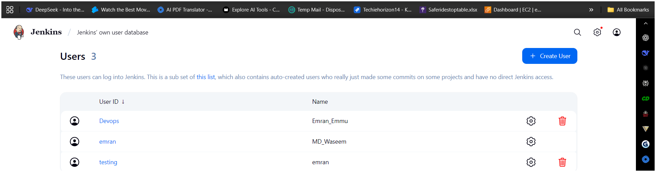
• Install Role-Based Authorization Strategy Plugin:
- Manage Jenkins → Manage Plugins → Available → Role-Based Authorization Strategy → Install
• Configure roles:
- Manage Jenkins → Configure Global Security → Authorization → Role-Based Strategy
• Manage Jenkins → Manage and Assign Roles → Manage Roles
- Create roles:
  - devops_role → Full control on build jobs only
  - testing_role → Read-only or limited job execution
• Assign roles:
- Manage Jenkins → Manage and Assign Roles → Assign Roles
  - Add users DevOps and testing with respective roles

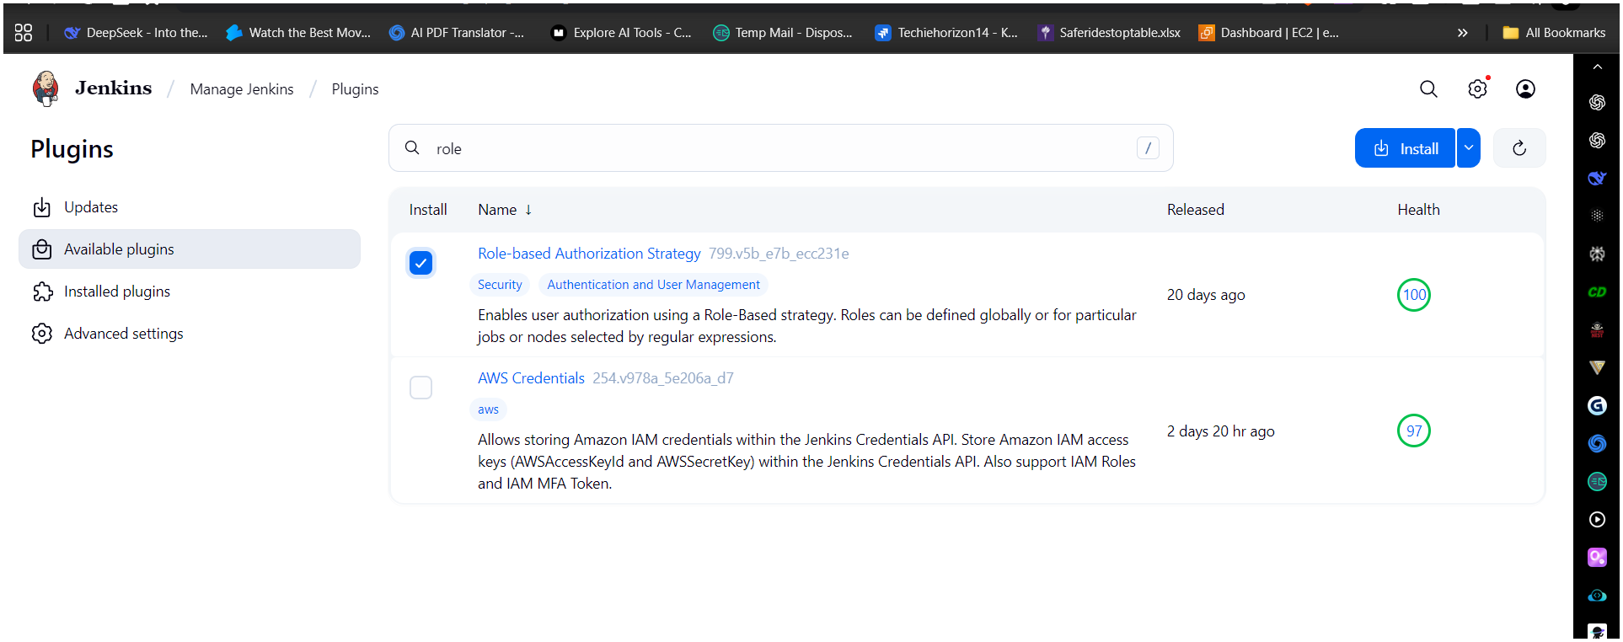
re-check
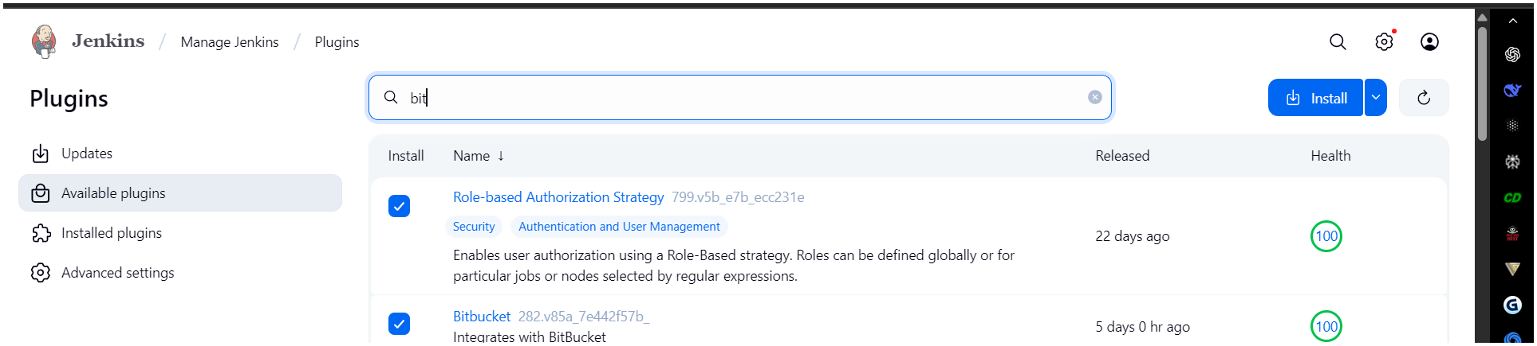
Manage Jenkins → security → authorization (project-based Matrix Authorization Strategy)
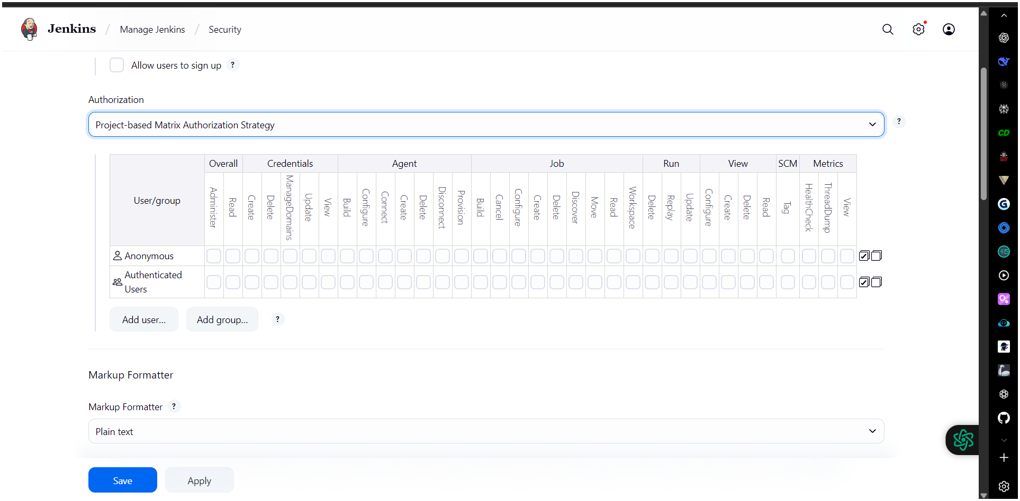
Here Emran_Emmu(Devops) && emran (testing)
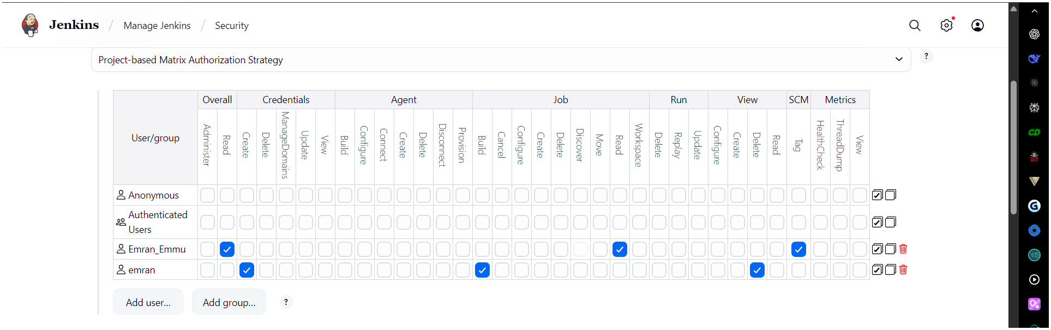
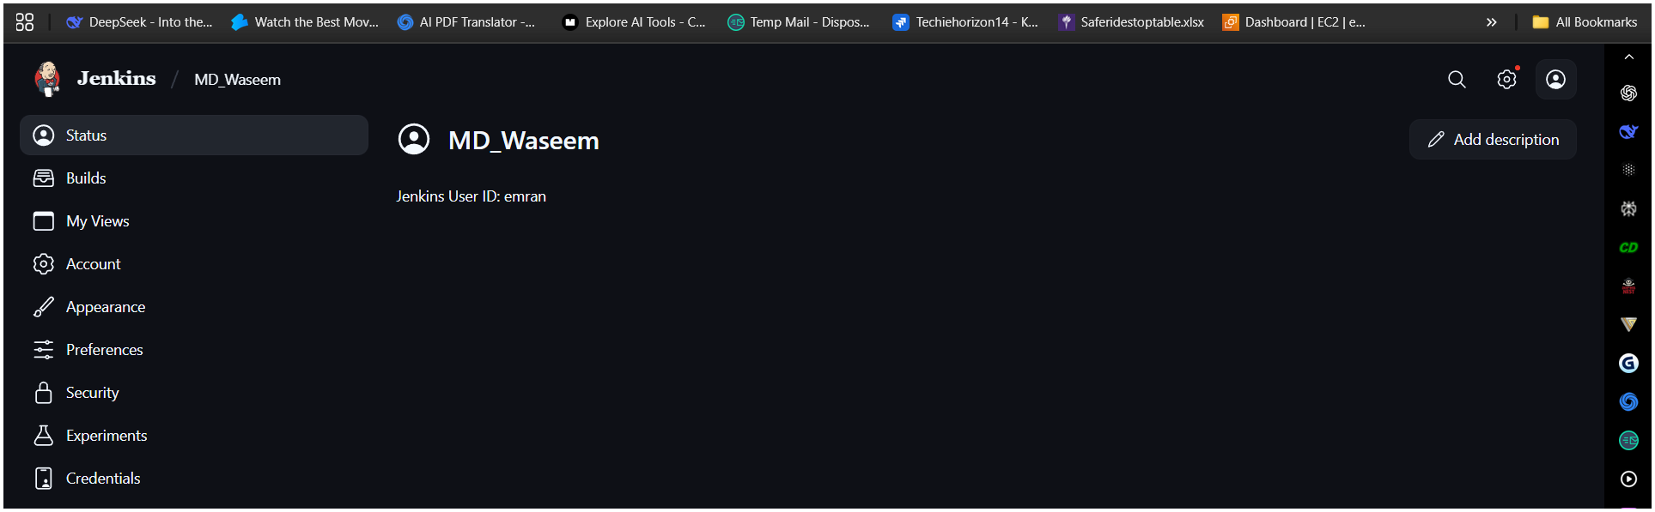
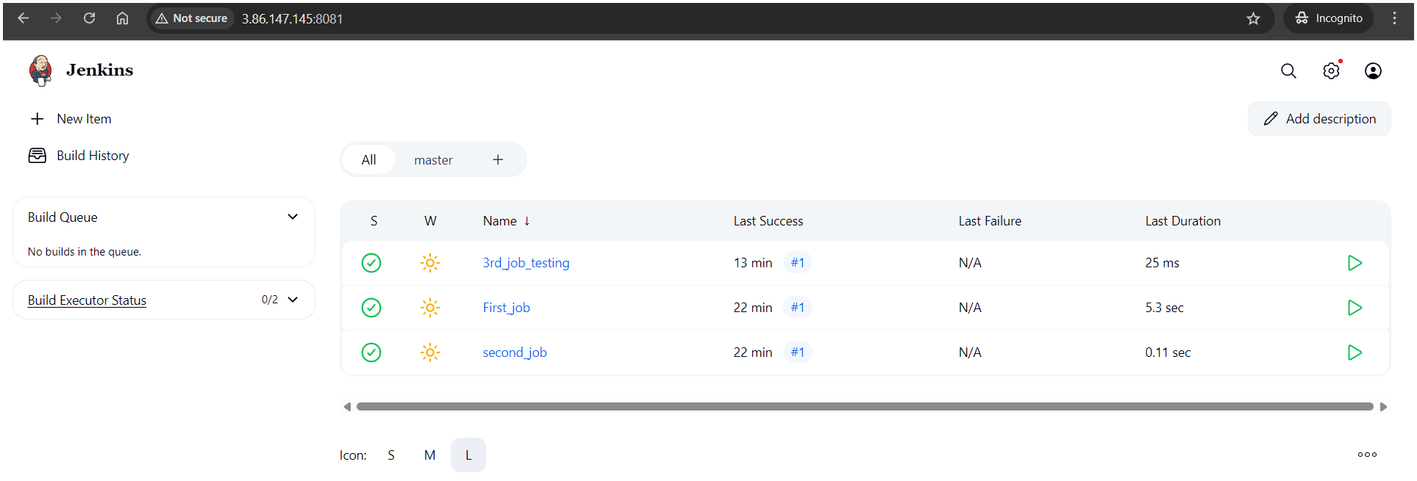
4) Configure labels and restrict the jobs to execute based on label only.
Install GIT
Manage Jenkins → system → create label Master
Create first job having label Master
Create second job without label Master
Create third job with wrong label hotfix
In each job → configure → build steps → execute shell → give
seconds.
ERROR getting due to directory issue. Got issue with disk space. While doing.
Manage jenkins → system → create label Master
. Create first job having label Master
. Create second job without label Master
. Create third job with wrong label hotfix
. In each job → configure → build steps → execute shell → give
seconds
. I Got an issue with disk space

Change Jenkins temporary directory (recommended)
. Point Jenkins to use /var/lib/jenkins/tmp (on your main disk, which
has ~18 GB free):
. Create a new tmp directory:
sudo mkdir -p /var/lib/jenkins/tmp
sudo chown -R jenkins:jenkins /var/lib/jenkins/tmp
. Add below temp file → sudo systemctl edit jenkins
. [Service]
Environment="JAVA_OPTS=-Djava.io.tmpdir=/var/lib/jenkins/tmp"
. Then reload
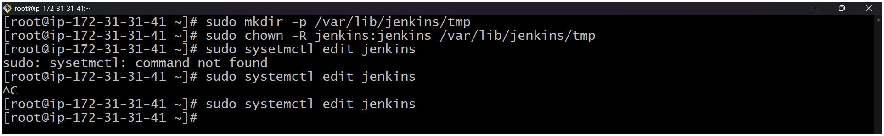
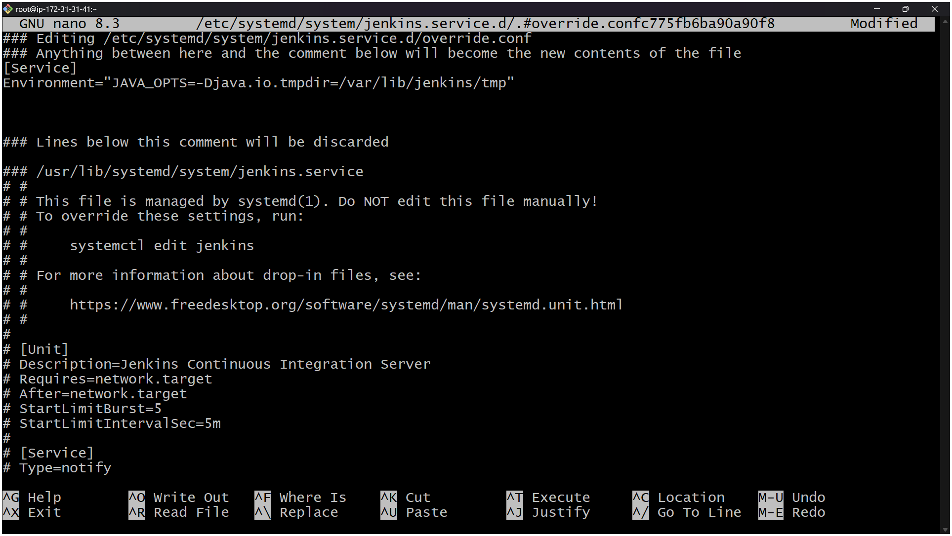
Ctl + o = to save the data
Enter the button
Ctl + x = to exit from the file
here we have restarted the Jenkins.
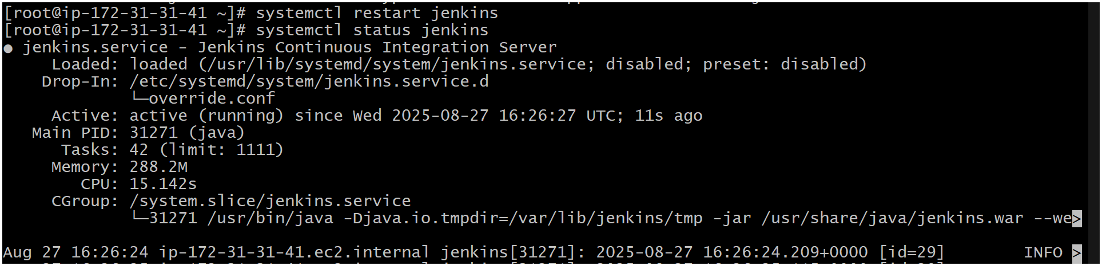
Change Jenkins temporary directory (recommended)
. Point Jenkins to use /var/lib/jenkins/tmp (on your main disk, which
has ~18 GB free):
. Create a new tmp directory:
sudo mkdir -p /var/lib/jenkins/tmp
sudo chown -R jenkins:jenkins /var/lib/jenkins/tmp
iii. Add below temp file → sudo systemctl edit jenkins
. [Service]
Environment="JAVA_OPTS=-Djava.io.tmpdir=/var/lib/jenkins/tmp"
. Then reload
sudo systemctl daemon-reload
sudo systemctl restart jenkins
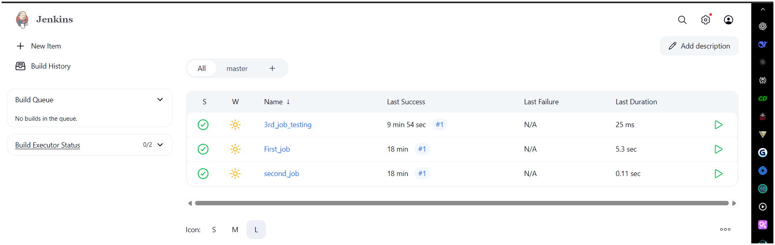

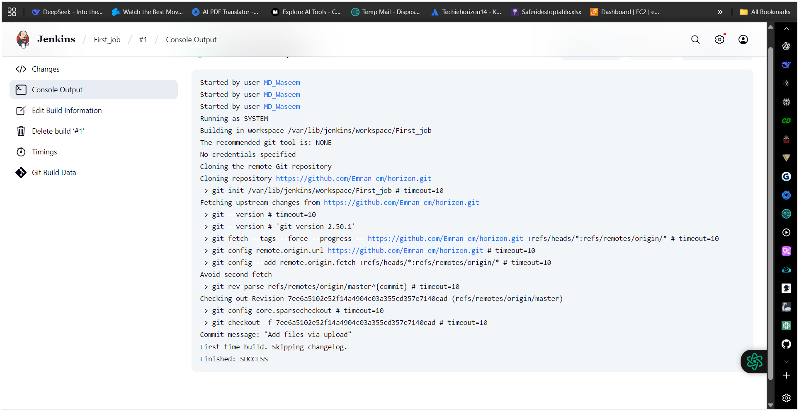
5) Create Three sample jobs using the below URL.
https://github.com/betawins/Techie_horizon_Login_app.git
Here I have use the above link to test. (sample_1st_job)
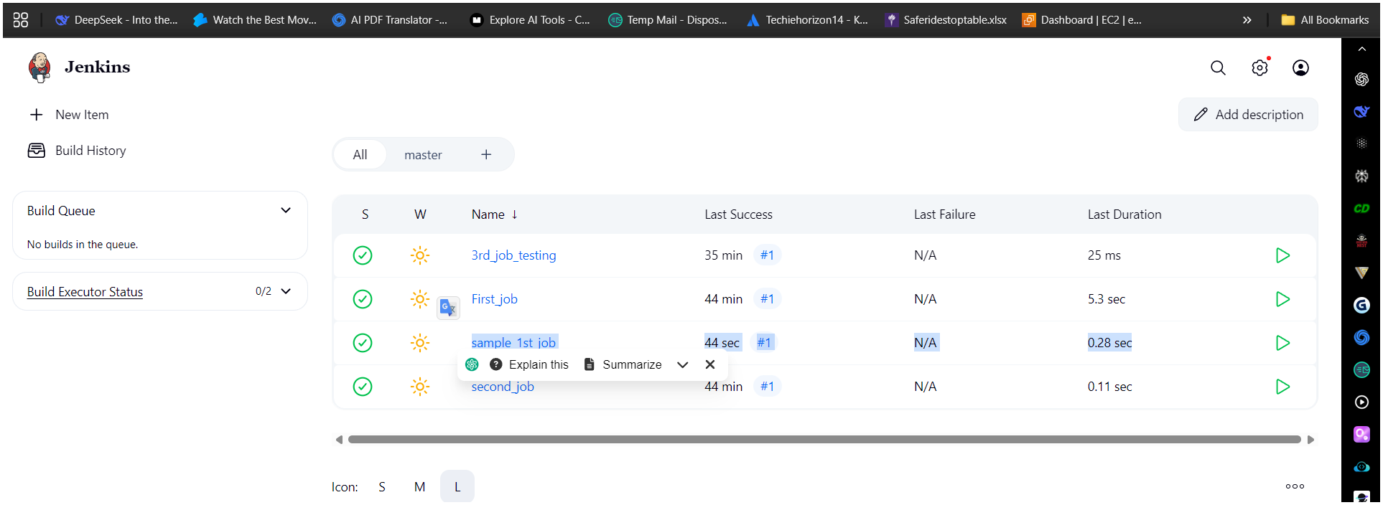
cd /var/lib/jenkins To enter in the junkins path
cd workspace
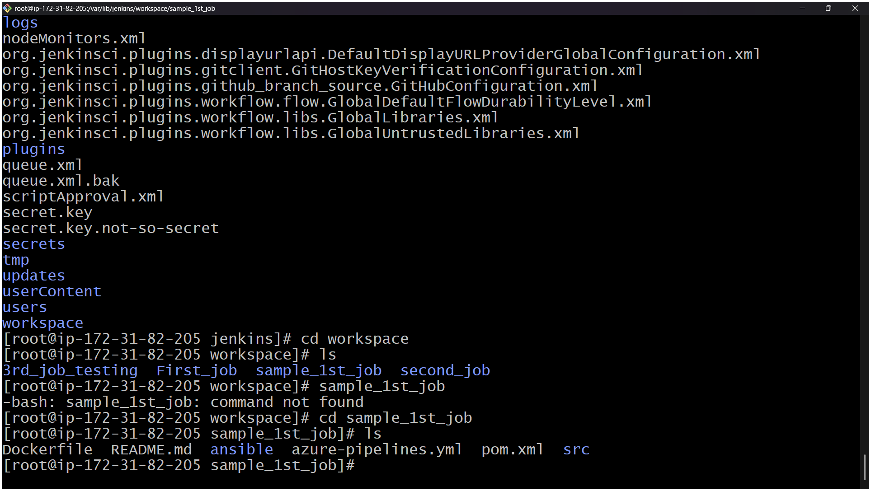
6) Create one Jenkins job using git hub Private repository.
GitHub
GitHub - betawins/Techie_horizon_Login_app
Contribute to betawins/Techie_horizon_Login_app development by creating an account
- Go to github and create access token with repo
Goto → github → settings → developer settings → personal access token (pat) →
Tokens (Classic) → Generate new token → Generate new token (Classic)
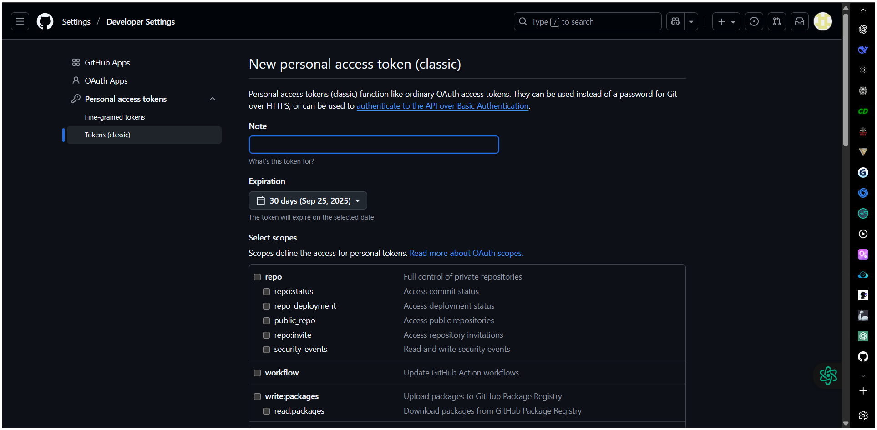

here we are creating access token for Jenkins ( job we need to add this in labels – credential’s --- )
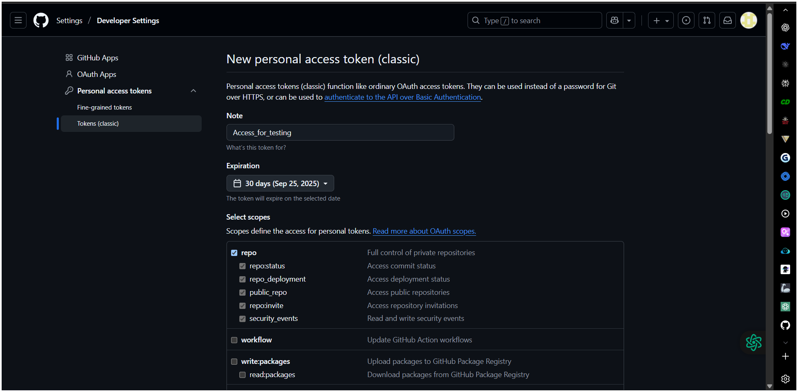
classic token is generated
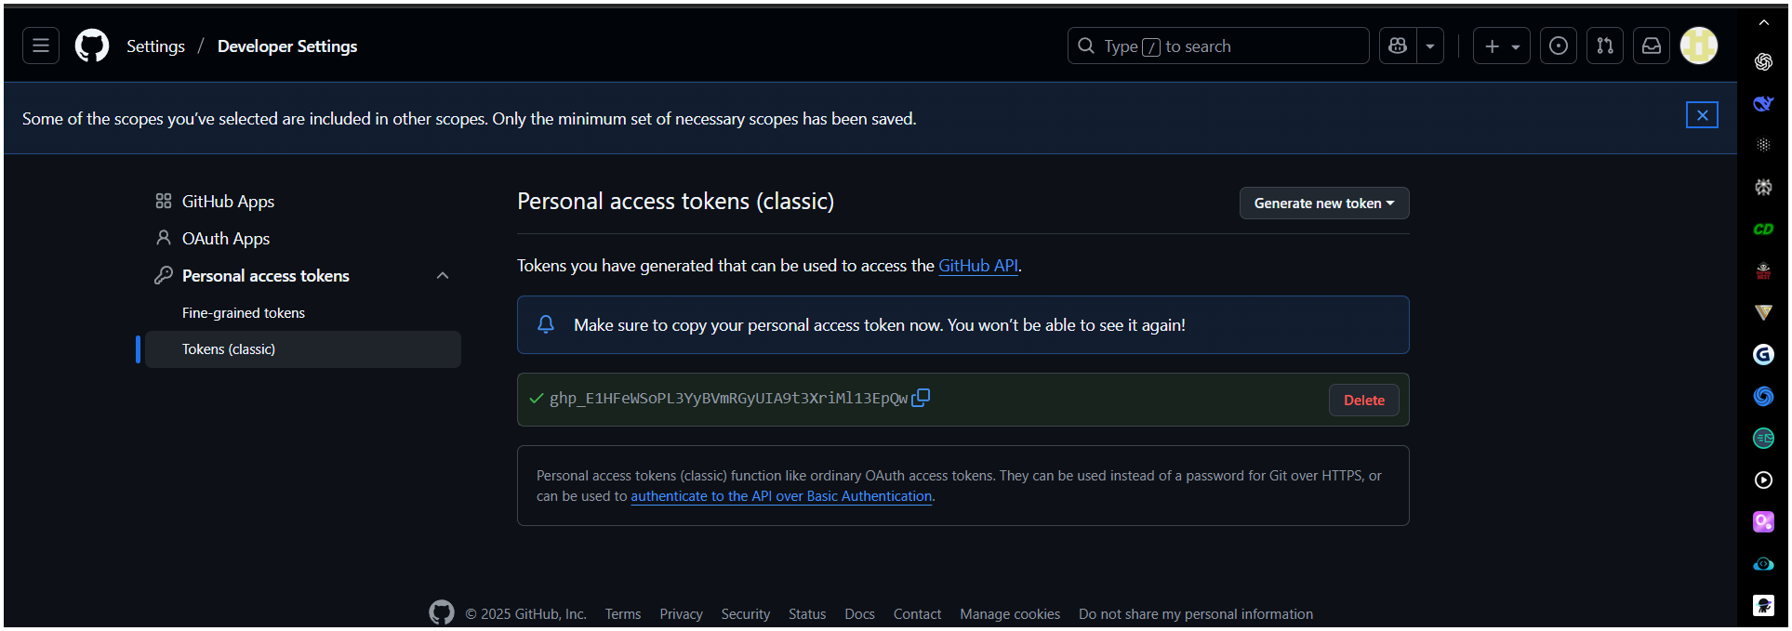
tap on system ( global )
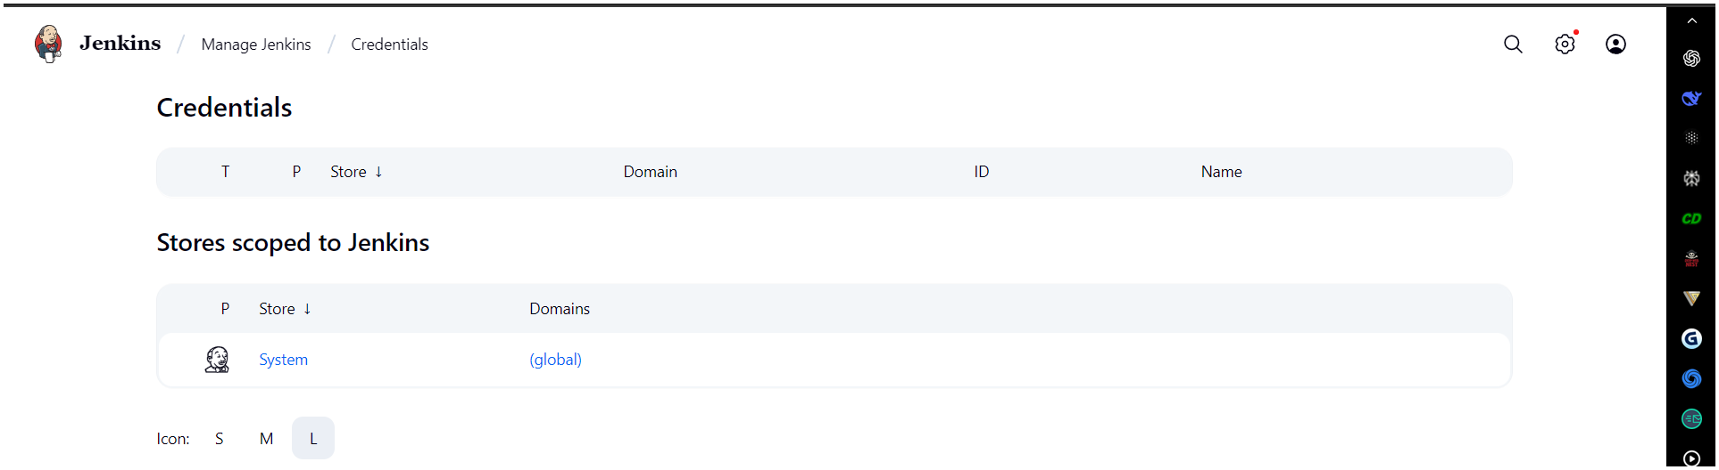
Add credential’s
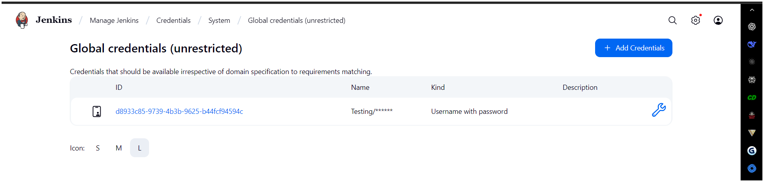
Add the below token / password in Add credentials and user name your choice.

- Just created a sample file for testing
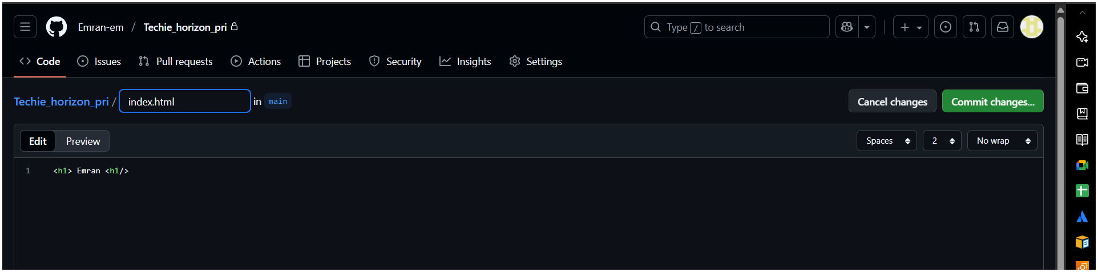
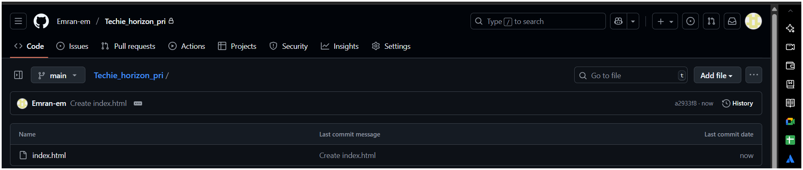
- Here you make sure have taken / choose main in pri repository of for GitHub
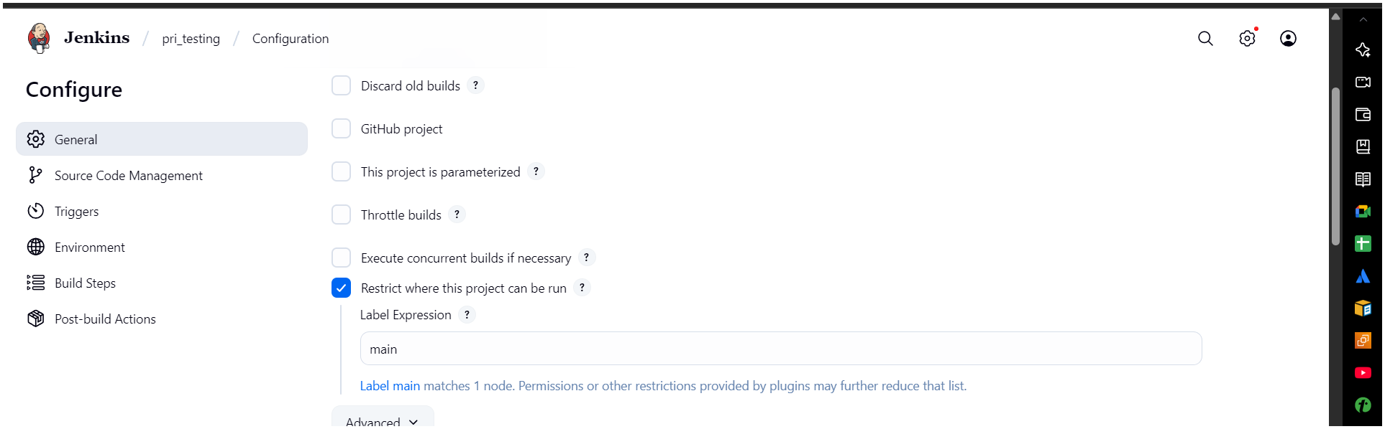
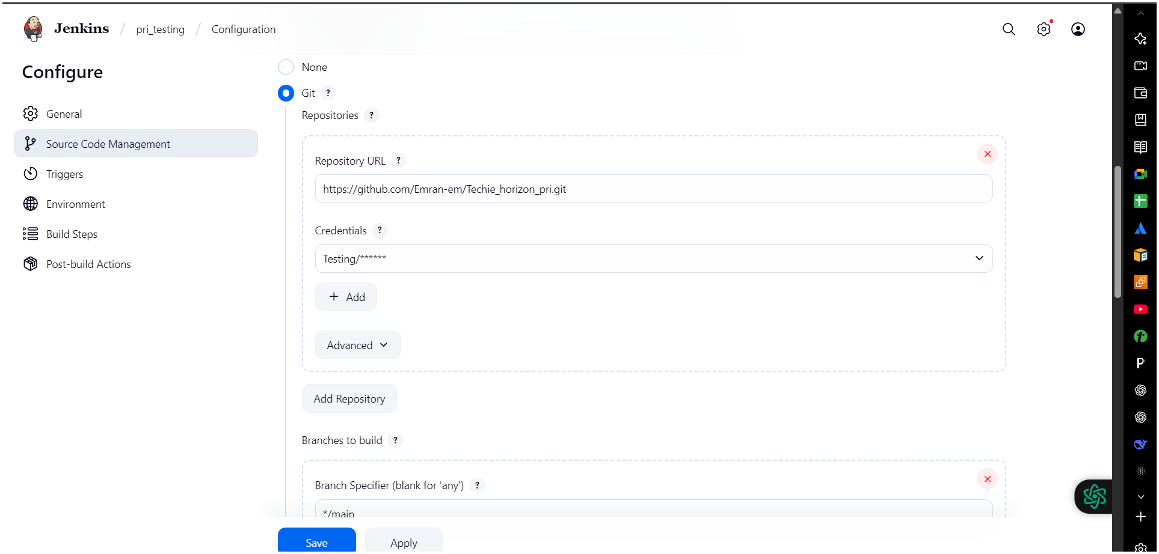
here over private repository is set ️
